**Report on Visual Information**

##### **Diagram 3**

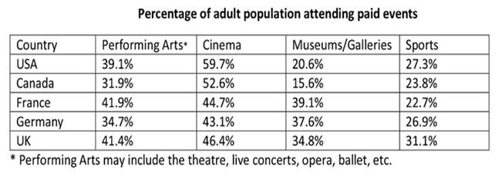

The table shows the percentage of the adult population attending paid events in five different countries. Overall, the most attended paid event was Cinema in all the countries and the least attended paid event was Sports in all the countries except the USA and Canada.

Turning to the column of cinema, it can be seen that cinema being the most attended paid event in all the countries was attended by more than half of the adult population in the USA and in Canada which as well holds the highest percentage of attendance in the USA among all other countries. Moreover, Attending performing arts comes second, which is more popular than sports and Museums in the USA and Canada. Furthermore, Sports events were attended by around one-fourth of the adult population in both the countries which makes them the third most popular event. However, museums/galleries are the least popular events in these regions.

Taking a look at the row of France and the UK, we can see that cinema and performing arts consecutively are the first and second most popular paid events with just over two fifths of the adult population attending performing arts. However, unlike the USA and Canada the third most attended paid event in these countries is museums/galleries making sports come in last which with more than a fifth of the adult population attending in France.

Contrastingly in Germany, the least popular event was sports which was attended by over a quarter of the adult population, and the second least popular event was performing arts. Furthermore, Museum/gallery events were the third least popular there, leaving cinema to be the most popular event that was attended by more than two fifths of the adult population.

To sum up, it can be inferred that cinema is the most popular and sports is the least attended paid event by the adult population in all the surveyed countries and the probable reason could be that cinemas bring infinite fictions and stories with great marketing that creates an exposure among adults wheres sports which due to technology boom is becoming underrated.